MAJOR-1 PROJECT

PROJECT REPORT

For

**PCause:** PCOS detection system based on deep learning model using ultrasound images.

# Submitted By

|  |  |  |
| --- | --- | --- |
| **Specialization** | **SAP ID** | **Name** |
| AIML Hons. | 500090912 | Charu Gupta |
| AIML Hons. | 500094127 | Lakshay Agarwal |



Artificial Intelligence Cluster

School of Computer Science

UPES Dehradun – 248007, Uttarakhand

Ms. Sugandha Sharma Dr. Anil Kumar

### Project Mentor Cluster Head

**Index**

|  |  |  |
| --- | --- | --- |
| **S. No.** | **Title** | **Pages** |
| 1 | **Abstract** | 3 |
| 2 | **Introduction** | 3 |
| 3 | **Literature Review** | 4 |
| 4 | **Problem Statement** | 5 |
| 5 | **Objective** | 6 |
| 6 | **Methodology** | 6 |
| 7 | **Algorithm** | 7 |
| 8 | **SEPM Model** | 9 |
| 9 | **Gantt Chart** | 10 |
| 10 | **References** | 10 |

**Synopsis Report**

**Project Title**

PCause: PCOS detection system based on deep learning model using ultrasound images.

**Abstract**

PCause will be a smart system designed to detect Polycystic Ovary Syndrome (PCOS) using ultrasound images. It will utilize complex but easy-to-understand techniques to process and analyze these images. It will enhance and select important information from the images using a method called Principal Component Analysis (PCA). Then, it will add more variety to the data using a special method called Generative Adversarial Networks (GANs). This will help make the system better at recognizing PCOS from different types of ultrasound images. This system will be a significant aid for doctors and patients dealing with PCOS in the future. It will find PCOS early, making it easier to treat. It will also assist doctors in planning treatments that are personalized for each patient. Additionally, it will be used for important research and to educate patients about their condition.

**Introduction**

In recent years, Polycystic Ovary Syndrome (PCOS) has become a common hormonal disorder affecting women of reproductive age, often leading to complications such as infertility and metabolic issues. However, diagnosing PCOS accurately can be challenging due to subjective assessments and reliance on manual interpretation of ultrasound images. The PCause project aims to address this challenge by developing an automated PCOS detection system using advanced technologies like deep learning and image processing. By analyzing ultrasound images, our system will provide healthcare professionals with a reliable tool for early and precise diagnosis. Our goal is to improve healthcare outcomes by streamlining the diagnostic process, enabling early intervention, and personalized treatment strategies for individuals with PCOS. Through collaboration with experts in both medical and technological fields, PCause strives to make a meaningful impact on women's health.

**Literature Review**

|  |  |
| --- | --- |
| Title | Inference |
| [Principal Component Analysis in Image Classification: A review](https://ieeexplore.ieee.org/stampPDF/getPDF.jsp?tp=&arnumber=10180847&ref=aHR0cHM6Ly9pZWVleHBsb3JlLmllZWUub3JnL2RvY3VtZW50LzEwMTgwODQ3&tag=1) [1] | Principal Component Analysis (PCA) as a pivotal tool for enhancing image classification in computer vision. PCA efficiently reduces the dimensionality of high-dimensional datasets, improving interpretability and visualization. The integration of PCA with convolutional neural networks (CNNs) demonstrates its role in optimizing computational efficiency and accuracy in classifying diverse datasets. Overall, PCA emerges as a crucial technique, simplifying complex data representations and contributing to the advancement of image classification methodologies in artificial intelligence applications. |
| [Classification of Ultrasound PCOS Image using Deep Learning based Hybrid Models](https://ieeexplore.ieee.org/document/10085400) [2] | The paper underscores the potential of advanced deep learning models, including Alexnet, Inception V3, Resnet50, and VGG16, in enhancing the accuracy of Polycystic Ovary Syndrome (PCOS) diagnosis from ultrasound images. The utilization of transfer learning techniques, particularly in the medical field, showcases the effectiveness of pre-trained models in image analysis. Additionally, feature selection, image pre-processing, and evaluation metrics like precision, recall, sensitivity, specificity, and F1 score play crucial roles in fine-tuning and evaluating the models. This research contributes significantly to advancing automated PCOS diagnosis, offering potential benefits for timely and accurate medical interventions. |
| [An extended machine learning technique for polycystic ovary syndrome detection using ovary ultrasound image](https://www.ncbi.nlm.nih.gov/pmc/articles/PMC9556522/) [3] | The paper proposes a pioneering approach for Polycystic Ovary Syndrome (PCOS) detection using a hybrid method that combines deep learning and traditional machine learning techniques. The study utilizes transfer learning with a pre-trained VGG16 model for feature extraction from ultrasound images. Compared to existing methods, the proposed approach achieves a remarkable accuracy in PCOS detection with efficient execution. While the method shows certain limitations that include a small dataset and challenges in explaining the model's decisions. The main aim of this research is to address such health issues and explore applications in detecting other clinical disorders. |
| [Generative adversarial network: An overview of theory and applications](https://www.researchgate.net/publication/348837975_Generative_adversarial_network_An_overview_of_theory_and_applications) [4] | Generative Adversarial Networks (GANs) uses image processing, emphasizing their role in generating realistic images through adversarial training. One of the impactful applications of Generative Adversarial Networks (GANs) in medical imaging, specifically in enhancing ultrasound image resolution. GANs integrated with deep learning models facilitate end-to-end encoding and decoding processes, enabling the generation of high-resolution images from routinely captured prostate ultrasound scans. Moreover, GANs are useful in creating different types of abnormalities in medical images, even when there are only a few examples available for each abnormality. The incorporation of deep convolutional GANs further enables the transformation of 2D images into 3D, expediting the analysis of medical images. |
| [Study and detection of PCOS related diseases using CNN](https://iopscience.iop.org/article/10.1088/1757-899X/1070/1/012062/pdf) [5] | Using Convolutional Neural Networks (CNN) as an image classifier, utilizing feature extraction attempts to effectively detect ovarian cysts in ultrasound images. The algorithm is trained on a dataset, using input ultrasound images as training data. It classifies test data within the dataset to determine if the ovary is affected, providing critical information on parameters such as area, solidity, extent, and perimeter affected by the cysts. This approach enhances diagnostic capabilities, showcasing the potential of CNNs in medical image analysis for precise identification and characterization of ovarian abnormalities, particularly in the context of disorders like Polycystic Ovary Syndrome (PCOS). |
| [Androgen receptor gene polymorphism and polycystic ovary syndrome](https://iopscience.iop.org/article/10.1088/1757-899X/1070/1/012062/pdf)  [6] | Polycystic ovary syndrome (PCOS) is a prevalent endocrine disorder in young women, characterized by ovulatory dysfunction, hyperandrogenism, and micropolycystic ovaries. Hyperandrogenism is the hallmark of PCOS, contributing to symptoms like hirsutism, acne, and anovulation. The androgen receptor (AR) gene, located in the Xq11–q12 region, has a polymorphic region in exon 1 comprising (CAG)n trinucleotide repeats. Variations in the length of these repeats affect AR activity and have been linked to androgen-related disorders. This systematic review aimed to assess the association between AR gene polymorphism and PCOS. The findings suggest that shorter CAG repeats may correlate with PCOS, indicating that AR polymorphism could serve as a potential biomarker for the disorder. However, conflicting results in the literature and limited data underscore the need for further studies to clarify this association and its implications for PCOS pathophysiology. |
| [Androgen receptor gene polymorphism and polycystic ovary syndrome](https://iopscience.iop.org/article/10.1088/1757-899X/1070/1/012062/pdf)  [7] | PCOS affects 5–10% of women, causing irregular periods, hormonal imbalances, and ovarian cysts. New diagnostic tools like AMH testing and treatments such as GLP-1 receptor agonists and SGLT2 inhibitors help manage insulin resistance, weight, and blood sugar. IVF and ICSI improve fertility, while minimally invasive options like UAE address complications like fibroids. Further research is needed to ensure long-term safety and personalized treatment. |
| A Smart Healthcare System Based on Classifier DenseNet 121 Model to Detect Multiple Diseases [8] | Recent research leverages DenseNet-121 for multi-disease detection in chest X-rays, addressing limitations in single-disease diagnosis. Using the ChestX-Ray8 dataset (108,948 images, 32,717 patients), the model identifies eight diseases and fourteen pathological conditions. Compared to radiologists, DenseNet-121 improves accuracy and efficiency, demonstrating AI’s potential in healthcare. This study highlights the role of deep learning in enhancing early detection and assisting medical professionals in diagnosing multiple conditions simultaneously. |

**Problem Statement**

The increasing prevalence of Polycystic Ovary Syndrome (PCOS) among women of reproductive age, coupled with the challenges of accurate diagnosis, underscores the urgent need for an automated diagnostic system. Traditional methods rely heavily on the manual interpretation of ultrasound images, which often leads to inconsistent results due to subjectivity among medical practitioners. Additionally, the manual diagnostic process is labor-intensive and time-consuming, placing a significant burden on healthcare professionals. Despite advancements in technology, there is a noticeable lack of tools that integrate advanced AI techniques for automated and reliable PCOS detection in a clinically usable manner. These limitations highlight the necessity for a system like PCause, which leverages advanced image processing and deep learning technologies to address these challenges. By automating the diagnostic process, PCause ensures early and accurate detection of PCOS, enabling personalized treatment strategies and improving healthcare outcomes.

**Objectives**

**Main Objective:** The primary objective of the current project is to develop an application for deploying a deep learning model to detect PCOS using ultrasound images. Additionally, we will create interactive dashboards for visualization, enabling users to analyze and interpret the results effectively.

**Sub objectives:**

* Creating user authentication
* Creating dashboard
* Uploading screen
* Prediction result screen

**Methodology:**

The methodology for PCause can be outlined as follows:

* **Authentication Screen**

The Authentication Screen is designed to allow users to securely log in or sign up for the application. It features a clean and user-friendly interface with separate tabs for login and signup. The login form includes fields for email and password, along with validation to ensure proper formatting and completeness. Similarly, the signup form collects user details such as email, password, and optional profile information. The forms are equipped with real-time validation to notify users of errors like invalid email formats or weak passwords. Firebase Authentication is used to handle user management, including secure login, registration, and error handling for cases such as incorrect credentials or existing accounts. Upon successful authentication, users are redirected to the Dashboard Screen.

* **Dashboard Screen**

The Dashboard Screen serves as the central hub, providing users with an overview of their past results, application features, and profile details. It is designed to display historical predictions, stored in Firebase Firestore, in an organized and interactive manner. The screen may include widgets for displaying results, such as a list view or card-based layout, and interactive charts for visualization. It also offers navigation to other parts of the app, such as the Image Upload or Prediction Screen, ensuring a seamless user experience.

* **Integrating the Model with the Application**

The model will be integrated into the application to allow users to upload ultrasound images through the Image Upload Screen. The model will process the image, generate the prediction results, and send them back to the app. The results will then be displayed on the Prediction Screen for the user in a clear and user-friendly format.

* **Image Upload Screen**

The Image Upload Screen allows users to upload ultrasound images for PCOS prediction. This screen features an intuitive interface with options to either select images from the device gallery or capture them using the camera. Flutter’s image_picker package is used to enable this functionality. The uploaded image is previewed on the screen, allowing users to confirm their selection before submission. Basic validation ensures that only valid image formats e.g., JPG, PNG are accepted, and the file size is within limits. The selected image is uploaded to Firebase Storage, and the metadata is stored in Firestore for further processing.

* **Prediction Screen**

The Prediction Screen displays the results of the PCOS detection analysis. After the image is processed by the backend model, the results are fetched and displayed in a user-friendly format. This includes whether PCOS was detected, a confidence score, and additional insights generated by the model. The screen may also feature visual aids, such as bar graphs or progress indicators, to enhance understanding. Firebase Firestore is used to retrieve the prediction data, ensuring real-time updates. This screen also allows users to save the results for future reference or share them directly with healthcare professionals.

**Algorithm:**

Algorithm for DenseNet-121 Implementation

Input: Preprocessed image dataset (e.g., ultrasound images for PCOS detection)

Output: A trained DenseNet-121 model for classification

1. **Data Preprocessing:**
   * Load the image dataset.
   * Resize all images to **224 × 224 pixels** (required input size for DenseNet-121).
   * Normalize pixel values to **[0,1]** for better training.
   * Apply **data augmentation** (e.g., rotation, flipping, zooming) to improve generalization.
2. **Initialize the DenseNet-121 Model:**
   * Load **DenseNet-121** as a pre-trained model (e.g., using ImageNet weights).
   * Remove the **fully connected (FC) layers** from the pre-trained model.
3. **Modify the Model for PCOS Detection:**
   * Add a **Global Average Pooling (GAP) layer** to reduce feature maps.
   * Add a **fully connected (Dense) layer** with activation functions (e.g., ReLU).
   * Use a **Dropout layer** to prevent overfitting.
   * Add an **output layer** with:
     + **Sigmoid activation** (for binary classification: PCOS vs. No PCOS).
     + **Softmax activation** (for multi-class classification).
4. **Compile the Model:**
   * Choose an **optimizer** (e.g., Adam or RMSprop).
   * Use a **loss function**:
     + **Binary Cross-Entropy** for binary classification.
     + **Categorical Cross-Entropy** for multi-class classification.
   * Define **evaluation metrics** (e.g., accuracy, precision, recall).
5. **Train the Model:**
   * Split data into **training, validation, and test sets**.
   * Train the model using **batch gradient descent** with backpropagation.
   * Use an **early stopping mechanism** to prevent overfitting.
6. **Evaluate Performance:**
   * Test the model on **unseen images**.
   * Generate a **classification report** (accuracy, precision, recall, F1-score).
   * Visualize **loss and accuracy curves**.
7. **Deploy the Model:**
   * Integrate it into a **web or mobile application**.
   * Accept new ultrasound images for real-time PCOS detection.

**SEPM:**

**Iterative Model**

We will be using the Iterative Model to implement our project. The iterative method begins with a basic implementation of a limited set of software requirements in the iterative model, then repeatedly improves the evolving versions until the entire system is built and prepared for deployment.

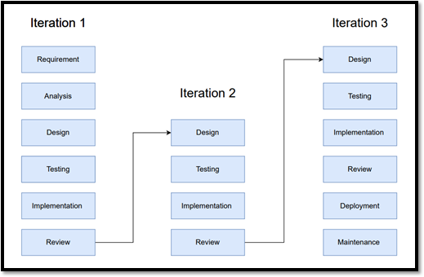It is not the goal of an iterative life cycle model to begin with a complete set of criteria. Instead, just a portion of the program is specified and implemented at the beginning, and then it is inspected to find any further requirements. After each iteration of the model, this procedure is repeated to create a new version of the program.

Fig. 1 Iterative Model

**Gantt Chart:**

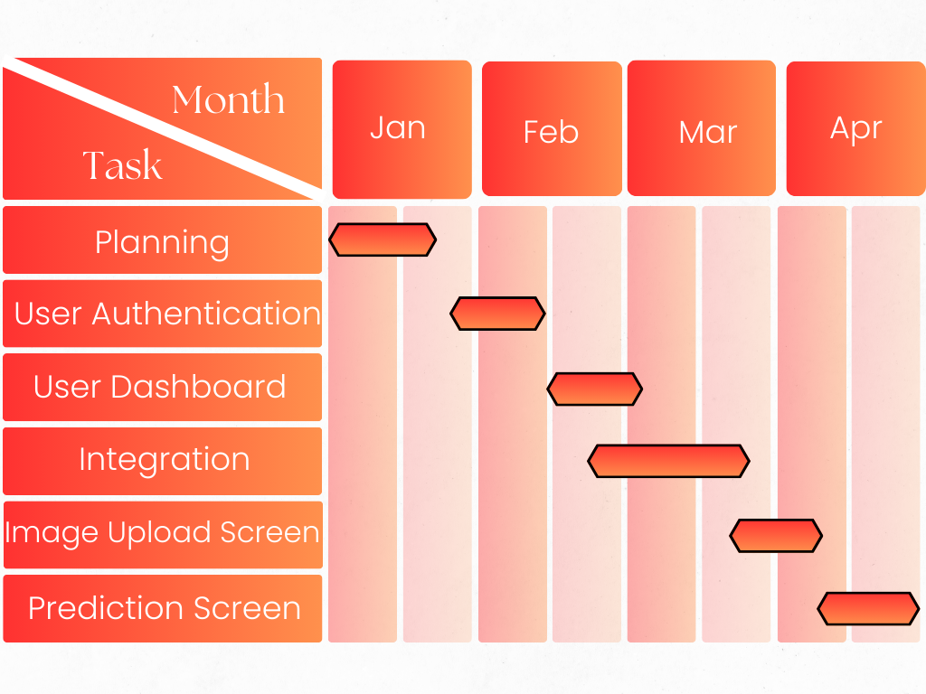

Fig. 2 Gantt Chart

**References:**

[1] Aslam, S., & Rabie, T. F. (2023, February). Principal Component Analysis in Image Classification: A review. In 2023 Advances in Science and Engineering Technology International Conferences (ASET) (pp. 1-7). IEEE.

[2] Chitra, P., Srilatha, K., Sumathi, M., Jayasudha, F. V., Bernatin, T., & Jagadeesh, M. (2023, March). Classification of Ultrasound PCOS Image using Deep Learning based Hybrid Models. In 2023 Second International Conference on Electronics and Renewable Systems (ICEARS) (pp. 1389-1394). IEEE.

[3] Suha, S. A., & Islam, M. N. (2022). An extended machine learning technique for

polycystic ovary syndrome detection using ovary ultrasound image. Scientific Reports, 12(1), 17123.

[4] Aggarwal, A., Mittal, M., & Battineni, G. (2021). Generative adversarial network: An overview of theory and applications. International Journal of Information Management Data Insights, 1(1), 100004.

[5] Sumathi, M., Chitra, P., Prabha, R. S., & Srilatha, K. (2021, February). Study and

detection of PCOS related diseases using CNN. In IOP Conference Series: Materials

Science and Engineering (Vol. 1070, No. 1, p. 012062). IOP Publishing.

[6] Lin LH, Baracat MC, Gustavo AR, et al. Androgen receptor gene polymorphism and polycystic ovary syndrome. Int J Gynaecol Obstet. 2013;120:115–118. doi: 10.1016/j.ijgo.2012.08.016

[7] Hai Bai, Huanhuan Ding, Mingming Wang. Polycystic Ovary Syndrome (PCOS): Symptoms, Causes, and Treatment. *Clin. Exp. Obstet. Gynecol.* **2024**, 51(5), 126.

[8] Chhabra, M., Kumar, R. (2022). A Smart Healthcare System Based on Classifier DenseNet 121 Model to Detect Multiple Diseases. In: Marriwala, N., Tripathi, C., Jain, S., Kumar, D. (eds) Mobile Radio Communications and 5G Networks. Lecture Notes in Networks and Systems, vol 339. Springer, Singapore.